Thanks for checking out our sermon-based Study Guides! If you’ve never used our Study Guides before, you’ll find some basic instructions beginning at the bottom of page 2.

NEW this year: These study guides will be written by thoughtful and experienced Life Group Leaders. As always, use these guides as a head-start in your own preparation as the needs and culture is different from each group. And of course, please continue to give us feedback.

Life Group Study Guide
for the Sermon given on September 25, 2022
by Pastor Bryan Wilkerson
“Encounters” - Exodus 3:1-15

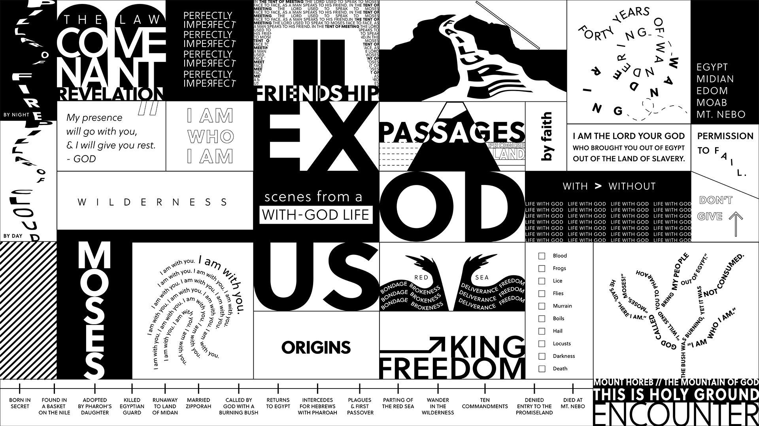

Question: Have you ever figured out who you are, and what you’re supposed to be doing?
Bottom Line: There are moments on everyone’s journey when God draws near and invites us into deeper relationship with Him.

-----

If this is your first time back, welcome to the new ministry year and if you took a break this summer, welcome back to this Life Group (new year, new name :)

Grace Chapel did something new for the start of the fall and that was to kick-off the year with “Vision Week” which included two Vision Sermons, the first week with Campus Pastors, and this past Sunday with Pastor Bryan beginning the new Fall Series called “Exodus.” Today we will be jumping right into the life of Moses, identify our points of connection, and consider what insights and wisdom we can apply to our lives.

We are excited to try to something a little new this year, and that is utilize some of the gifting and passion of talented and experienced group leaders and so much of this study has been created by one of our seasoned Life Group Leaders. Thank you for being here today.

Let’s begin in prayer before we begin reading and discussing our text.

Main Scripture Reading: Exodus 3:1-15

Moses and the Burning Bush
3 Now Moses was tending the flock of Jethro his father-in-law, the priest of Midian, and he led the flock to the far side of the wilderness and came to Horeb, the mountain of God. ² There the angel of the Lord appeared to him in flames of fire from within a bush. Moses saw that though the bush was on fire it did not burn up. ³ So Moses thought, “I will go over and see this strange sight—why the bush does not burn up.”
⁴ When the Lord saw that he had gone over to look, God called to him from within the bush, “Moses! Moses!”
And Moses said, “Here I am.”
⁵ “Do not come any closer,” God said. “Take off your sandals, for the place where you are standing is holy ground.” ⁶ Then he said, “I am the God of your father,^{[a]} the God of Abraham, the God of Isaac and the God of Jacob.” At this, Moses hid his face, because he was afraid to look at God.
⁷ The Lord said, “I have indeed seen the misery of my people in Egypt. I have heard them crying out because of their slave drivers, and I am concerned about their suffering. ⁸ So I have come down to rescue them from the hand of the Egyptians and to bring them up out of that land into a good and spacious land, a land flowing with milk and honey—the home of the Canaanites, Hittites, Amorites, Perizzites, Hivites and Jebusites. ⁹ And now the cry of the Israelites has reached me, and I have seen the way the Egyptians are oppressing them. ¹⁰ So now, go. I am sending you to Pharaoh to bring my people the Israelites out of Egypt.”
¹¹ But Moses said to God, “Who am I that I should go to Pharaoh and bring the Israelites out of Egypt?”
¹² And God said, “I will be with you. And this will be the sign to you that it is I who have sent you: When you have brought the people out of Egypt, you^{[b]} will worship God on this mountain.”
¹³ Moses said to God, “Suppose I go to the Israelites and say to them, ‘The God of your fathers has sent me to you,’ and they ask me, ‘What is his name?’ Then what shall I tell them?”
¹⁴ God said to Moses, “I am who I am.^{[c]} This is what you are to say to the Israelites: ‘I am has sent me to you.’”
¹⁵ God also said to Moses, “Say to the Israelites, ‘The Lord,^{[d]} the God of your fathers—the God of Abraham, the God of Isaac and the God of Jacob—has sent me to you.’
“This is my name forever,
the name you shall call me
from generation to generation.

Group Discussion Questions

- Pastor Bryan made reference to the Beatles’ song, Nowhere Man. “He’s a real nowhere man, living in his nowhere land, making all his nowhere plans for nobody.” Can you relate to these lyrics now, or at any time your life? Please tell us when and explain the context.
- In verse 3 Moses takes a moment to consider whether to take a closer look at the burning bush or keep walking. Why do you think the writer(s) of Exodus included this pause in the story? Can you think of similar moments you may encounter in the course of a week?
- Skye Jethani proposed 5 ways that people typically relate to God: life under God, life over God, life from God, life for God, and life with God. Which of best describes how you view your relationship with God?
- Looking back on your life, think about the times you may have encountered God. When and where was it? What were you doing? What captured your attention? What decision did you make?
- If you had an opportunity to complete the Discipleship Planning Tool and/ or the GPS Assessment, please share your results with your group and discuss where you think God may be calling you to serve.

Homework Until Next Time:
Ask the members of your LG to complete the Discipleship Planning Tool and the GPS Assessment Tool before your next meeting. Here is some fresh language:

We’re all on a journey; where is yours taking you?

The beauty of the way of Jesus is that it’s not just good for us, it’s good for the world around us. But that kind of beautiful life doesn’t come from just hearing the words of Jesus; it comes from putting them into practice. Three kinds of practice, actually:
- The with-God life of our personal habits and routines;
- The with-others life of our genuine and life-changing relationships; and
- The for-the-world life that makes an impact beyond our immediate homes and families, into our communities and beyond.

Growing as disciples of Jesus will make a Kingdom difference in our world and a transformative difference in our lives as believers and as a group. And these resources are helpful in identifying the next steps for our journeys.

Let’s Pray
-------------------
Support for the Leader (These Teaching Points are provided to help the group leader make connections from the message to their group with both insights from the Biblical text and also opportunities in the life of our church).

Teaching Points:
- If you have not yet done so, please spend 15-20 minutes to complete the Discipleship Planning Tool (grace.org/the journey) and the GPS Assessment Tool (grace.org/volunteer)
- Like Moses, we all have moments in our daily lives when we see something, hear something or feel something that gets our attention. We have a decision to make. Do we explore it or ignore it? Could some of these moments be God inviting us into a deeper relationship with Him?
- God takes the initiative and then waits for us to respond. If we don’t pay attention to what is going on around us and pause to think about these particular moments, we might be missing an opportunity to play a unique role in God’s story.
- God is always doing something new in our lives and in the church. Will you be present to what God might be inviting you into this season?
- You’ll never really know who you are, until you know that God is with you.

For Further Biblical Study:

Genesis 22:1 (NIV)
Some time later God tested Abraham. He said to him, “Abraham!” “Here I am,” he replied.

Genesis 46:2 (NIV)
And God spoke to Israel in a vision at night and said, “Jacob! Jacob!” “Here I am,” he replied.

Isaiah 43:19 (NIV)
See, I am doing a new thing!
Now it springs up; do you not perceive it?
I am making a way in the wilderness
and streams in the wasteland.

Matthew 28:18-20 (NIV)
¹⁸ Then Jesus came to them and said, “All authority in heaven and on earth has been given to me. ¹⁹ Therefore go and make disciples of all nations, baptizing them in the name of the Father and of the Son and of the Holy Spirit, ²⁰ and teaching them to obey everything I have commanded you. And surely I am with you always, to the very end of the age.”

How to Use These Study Guides:
- Consider sending out the Scripture passage to your group members ahead of time.
- Begin each meeting with a short time of checking in with one another.
- You may want to begin the discussion by reading the Scripture passage together out loud, or by summarizing the passage if everyone has read it ahead of time.
- Don’t feel like you need to discuss every question included in the Study Guide. Pick one or two to start with, and see how the conversation flows.
- If your group meets over Zoom:
  - You may need to do more overt facilitating over Zoom than you would in person. Feel free to call on people to invite them to share.
  - Try to be sensitive to attention spans over Zoom—keep the meetings shorter than they would be in person.
- Be sure to set aside time for sharing prayer requests and praying together.

Group Leader Support: Please reach out to your Campus Pastor or your Coach if you have any questions about leading your group or concerns about your group dynamic. If you have questions about or feedback on the Study Guides, please reach out to Pastor Tim or Pastor Rachel from the Group Life team.

