Leader Resources 2019-2020
One of our renewed commitments to Group Leaders is to invest into your leadership development. We want you to not only grow in your small group leadership but also in all the aspects of your overall leadership. Which is why we are recommending resources on both levels.

Campus and Central Pastors and Coaches are available to serve you as you continue to discover and grow in your unique gifting. We want you to grow as group leader and grow in your overall leadership as you live and serve the Kingdom and the world at large.

Below are resources across various mediums (books, videos, podcasts, etc.) that we have selected to help you in the many aspects of leader development.

If there’s a particular resource or tool that has helped you, please let us know for consideration on this list in the future.

Suggested Books

The Ruthless Elimination of Hurry: How to Stay Emotionally Healthy and Spiritually Alive in the Chaos of the Modern World
By: John Mark Comer
Click Here

Why We’re Recommending It: John Mark Comer tells a story of as his church was growing and his career surging, he was on the verge of burn-out and an emotional breakdown. He later learned that “Hurry is the great enemy of the spiritual life.” In short, this book is for everyone who feels rushed, anxious or overwhelmed. Filled with great perspective and practices, these words can help you eliminate the hurry and deepen your soul.

It even has its own - Podcast Here

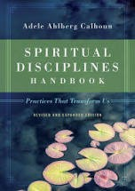
Spiritual Disciplines Handbook - Adele Calhoun Click here to purchase the book from Amazon.

Why we’re Recommending it:

To be a spiritual leader, we need to be growing in our spiritual formation and to do that, we need to discover and practice the spiritual disciplines.

Author and Pastor Adele Calhoun is an expert on the disciplines and many of us on staff have benefited from her wisdom, her approach and this book.

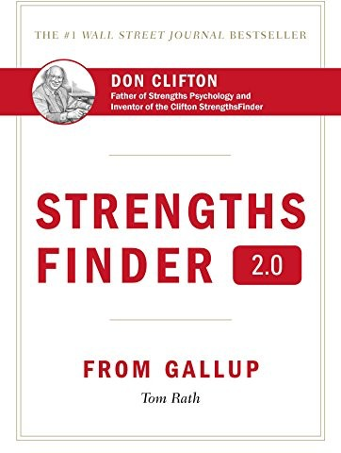
Strength Finder- Tom Ruth
Click here to purchase the book from Amazon.

Why We’re Recommending it:

If you have never taking the Strength Finders test, let’s remedy that as soon as we can because it is enlightening! Author Tom Roth identifies 34 different strengths that leaders and innovators have and unpacks them in insightful and practical ways. Your results really will illuminate hidden qualities of your gifting and potential and we’d love to encourage you to dive in.

Leader to leader hint: Read the introductory chapters, take the Strength Finder test, print out the result and read the chapters with the strengths identified first.

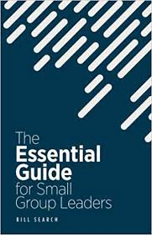
The Essential Guide for Small Group Leaders – Bill Search Click here to purchase the book from Amazon.

Why’re Recommending It:
Filled with one-page quick nuggets of wisdom for small group leaders, this little book packs a lot of perspective. It’s a great supplement between trainings and covers some specific topics like “Ask Great Questions” or “Get the Off-Track Back On Track” and about 60 other micro-chapters. Could be a helpful guide in the busy, everyday grind of the ministry year.

Suggested Videos

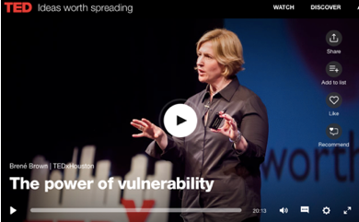

TED Talks on Leadership:

Why and What We are Recommending:

After creating a free log-in account on TED.com, you can watch world-class leaders from a plethora of topics. We recommend watching talks on leadership and you can easily do that by watching from TED’s “playlist” on Leadership.

Perhaps begin with Brené Brown’s runaway viral talk on the “Power of Vulnerability.”

Leading with vulnerability is often misunderstood and often neglected.

After that, consider this particular 12 talk playlist on leadership called, “How Leaders Inspire.” You could literally spend the remainder of your lifetime watching all the available talks on the wide range of topics so consider creating a free account, watch online, or download the app and consider this a library of free knowledge from world-renowned experts at your disposal.

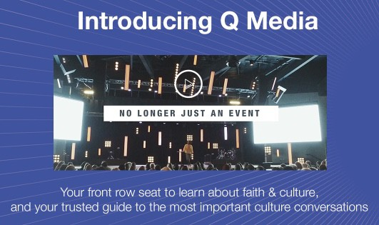
Q Media – Click here to learn more

What is it? And Why We’re Recommending It:

Think of it as a mini-Netflix channel for our cultural conversations informed largely by a Christian viewpoint. Q Ideas gathers communicators and leaders around the challenging topics in our society.

We believe groups can be a place for us to learn new ideas, respectfully share our perspectives and be challenged by the convictions of others.

This is a brand-new resource that we are looking for a few groups to experiment for us. This is also listed in the Resources for Groups 2019 as you can use this resource for groups and you can also watch talks to help you in personal leadership development and Kingdom-posture towards the common good of society.

You can stream the content on a smart-tv, handheld device. Q Talks are TED Talk style and are either ether 9 or 18 minutes long and each talk has a set of discussion questions on its talk page.

Would love to set you up with your account, please contact Pastor Tim Ghali directly to get access (and he wants your feedback for the future of this resource).

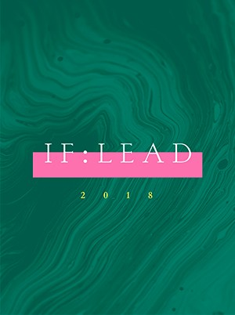
IF: Lead Talks

Why We’re Recommending It:
You are a leader with an important calling: to make disciples. Maybe you know that clearly, or perhaps you are just starting to believe that. Join the women of IF:Lead to recapture the joy of making disciples in everyday circumstances. The IF:Lead is an annual gathering specifically created to pour into leaders who are creating environments for discipleship in their hometowns. Gain insight and wisdom from some of today’s up and coming women leaders at this Right Now Media link.

Suggested Podcast

Why We’re Recommending Podcasts:

You’re busy - we get it. And it’s hard to find time to read and watch all the incredible content you plan on. Podcasts have soared in popularity because of their convenience to listen to and the ability for podcasters to get their timely content to you quickly and directly to your smart phone/device.

There are hundreds of amazing podcasts, and here are a few that we currently have on our rotation.

Group Answers Podcast with Chris Surratt and Brian Daniel Check out the podcast here.

“The Group Answers Podcast is a weekly show designed to resource, train, and encourage small group leaders. Each episode considers current trends and resources as well as timeless truths and methods of discipleship. It is hosted by Brian Daniel, a Bible study and discipleship expert in LifeWay’s Groups Ministry, and Chris Surratt, the small group and discipleship specialist at LifeWay and author of Small Groups For The Rest Of Us.”

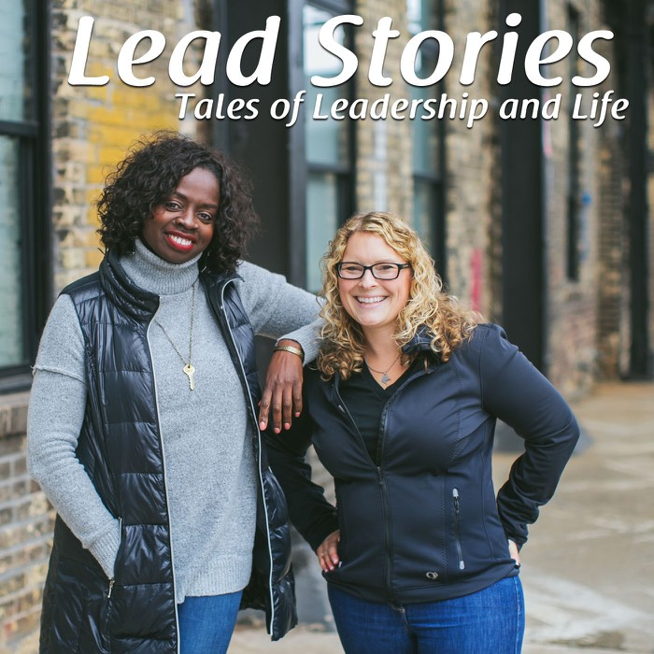
The Lead Stories Podcast

This weekly podcast is co-hosted by Jo Saxton and Pastor Steph O’Brien and centers on the intersection of leadership and life. Jo and Steph (and their special guests) explore the challenges and opportunities around leadership with honesty and transparency, encouraging their audience to step into their God given influence with courage and intentionality.

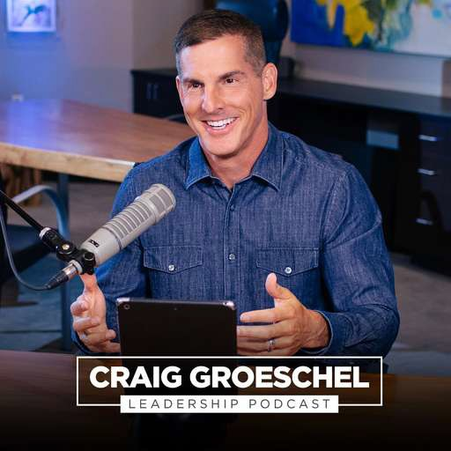
Craig Groeschel Leadership Podcast

“The Craig Groeschel Leadership Podcast offers personal, practical coaching lessons that take the mystery out of leadership. In each episode of the Craig Groeschel Leadership Podcast, Craig brings you empowering insights and easy-to-understand takeaways you can use to lead yourself and lead your team. You’ll learn effective ways to grow as a leader, optimize your time, develop your team, and structure your organization.”

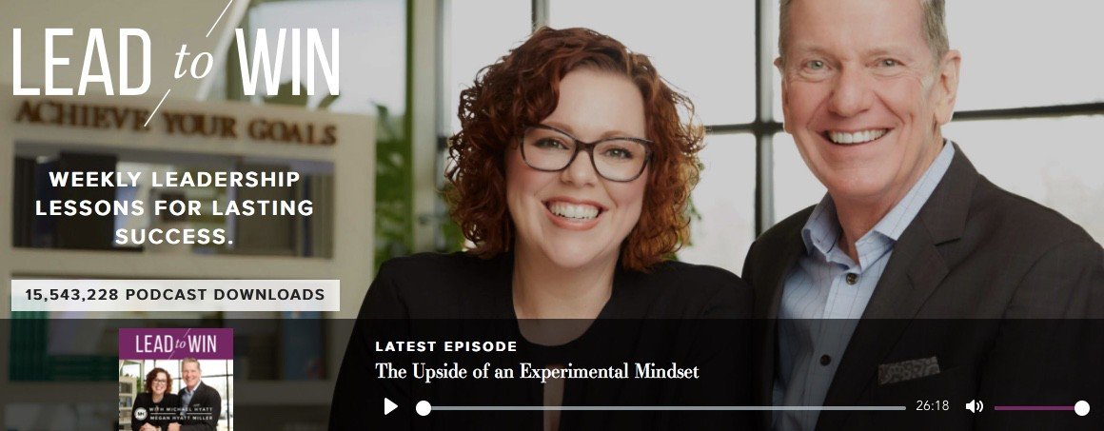
Lead to Win with Michael Hyatt

Michael Hyatt is an incredible thinker on ideation and productivity. He has helped thousands of people from all walks of life to discover their leadership potential and help in their leadership, productivity and fulfill their passions in meaningful ways. His podcasts feature guests and topics like “How to Fail Better” and “5 Steps for Healthy Confrontation.” Check out the podcast here.

*Looking for something not on this list? Pastor Tim would love to hear from you.

