Resources for Group Studies – Winter 2020

How to use this guide:
Studying Scripture and Christian teaching in community is a needed element in our personal transformation and how groups become closer relationally and stronger spiritually.

Truth is, it takes more than the selection of a study. Healthy groups are creating an environment to learn content, to glean from one another, to be curious and wonder, and to search and pray. We pray that each of our groups has a vibrant spiritual culture where the Holy Spirit is invited to be at work.

Further, changing up the “medium” of study is an important factor in leading effective studies. Meaning, one series could be a book study, another could be video based, another could be curriculum based, another could be the inductive Bible study
guides. You will want to change the medium, and consider rotating teachers, if those gifts exist in your group.

Our vision for group life is “people who gather in community practicing the way of Jesus.” Our resource list reflects three core values of group life that we believe cultivates practicing the way of Jesus. These include: Spiritual Formation, Missional Living, and Strengthening Relationships.

Most of these studies require minimum financial purchase; our video-based ones from RightNow Media only require a free account that you can set-up here.



Spiritual Formation
Complimentary to our Fall Sermon Journey, some other options to consider:


Sermon on the Mount -
Jenny Wilken

Why We’re Recommending It:
Jenny asks, “What does it mean to be a citizen of the kingdom of Heaven? Matthew's gospel opens with three chapters containing Jesus' longest recorded message – a sermon given to His disciples early in His ministry to articulate what the life of a Christ-follower would look like.
Our Groups for Women in Lexington will be studying this video-based study taught by Jenny Wilken on the Sermon on the Mount. Consider beginning this new year and this new decade by learning and applying Jesus’ profound and life-transforming teachings for Christ-followers.

Similar to our Winter series "Googling God”:
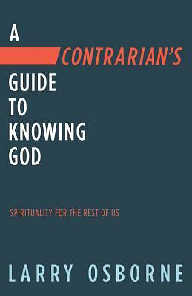
A Contrarian’s Guide to Knowing God - Larry Osborne
https://www.rightnowmedia.org/Content/Series/257965?episode=Trailer

Why We’re Recommending It:
Larry Osborne is the lead pastor of North Coast Church (near San Diego) which is a ministry that revolves around their small groups. We tend to like Larry’s content as it is conducive for small groups - the video teaching is under 15 minute, point to discussion, and in tune with today’s world. This study plays special attention to the part of us that wonder about God but still can’t help but ask, “Yeah but …” It’s recommended that you watch the trailer video, and preview as many sessions as you can to see if this will serve your group well.

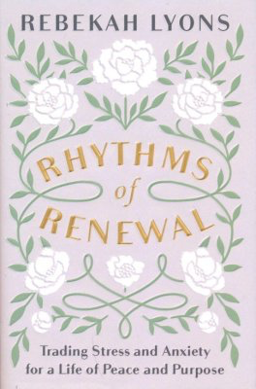
Rhythms of Renewal - Rebekah Lyons
Why We’re Recommending It:
Drawing from her how battles with depression and anxiety, Rebekah’s new work focuses on the practices of Rest, Restore, Connect and Create.
She teaches that we naturally do well with and that our lives would be enriched if we incorporate these rhythms to our lives. All of us feel busy, over-scheduled and looking for more, consider if these Rhythms of Renewal is what you and your group need to begin this new year.

Click Here:

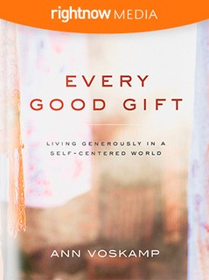
Every Good Gift - Ann Voskamp - https://www.rightnowmedia.org/Content/Series/361050

Why we’re recommending It: Ann asks, “How natural is generosity to who you are? What do you do with what you have?” and invites us to ex amine what Bible says about hospitality, generosity, and stewardship.

Tethered to biblical accounts of giving, this six-session series with author and speaker Ann Voskamp explores examples of offering hospitality, time, money, spiritual gifts, and empathy to the glory of God.

Accompanying the video series is a free Leader’s Guide (there is a study guide available as a small purchase) and each video is about 15 minutes long, giving you plenty of time for facilitated discussion.

The Book of Galatians - Kyle Idleman
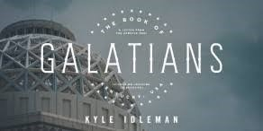

(video-based curriculum from RightNow Media)

Why we’re recommending it:
We wanted to offer a video option for those groups that wanted a video curriculum. Kyle Idleman is an effective Bible teacher and we love that it’s a 6 sessions series and each one is under 12 minutes in duration, leaving plenty of time to discuss the passages together.

Click here for the RightNow Media link to the videos, leader’s guide, and participant
handouts.

Emotionally Healthy Spirituality - Peter Scazzaro
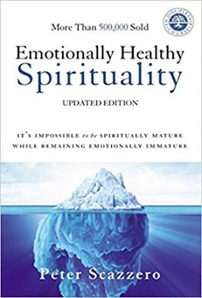

Why We’re Recommending It:
According to group leader feedback, Scazzaro’s Emotionally Healthy Spirituality has been a
widely appreciated study and we happily recommend it for groups that have been meeting for a few years and want to go deeper in their understanding of their personal and collective spiritual formation. We encourage you to read the book alongside the small group discussion guides.

Click here for published Group Leader guide and packet.

Why We’re Recommending It:

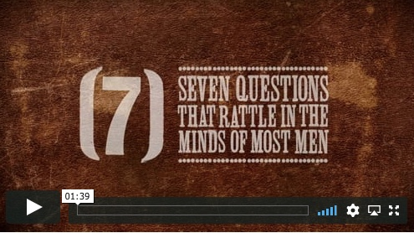
We’re getting a lot of great feedback from a group for men in Foxboro. It’s a 7-part video series led by teacher John Woodward and each part clocks in around 7-9 minutes covering a variety of topics including: identity, marriage, parenting, career, success and the different seasons of a man’s life (which in itself was powerful).

Here’s the link to the videos and leader guide - https://groupleaders.org/seven

We’d like to encourage each participant to make the small investment in purchasing the discussion guide - you can get a group discount and make a commitment to study this resource together. https://store.northpoint.org/products/7-questions-study-guide

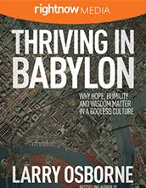
Thriving in Babylon - Larry Osborne
https://www.rightnowmedia.org/Content/Series/163627
Why We’re Recommending It:
Larry describes how these are confusing times for many Christians and asks, how can we spiritually survive in an increasingly spiritually hostile environment? And is there any hope for the next generation?

This is a 5-session series on the book of Daniel, a believer committed to worshiping God in his new society that he was forced to live in. What wisdom, hope, and love can we learn from him?

We like that each session also includes stories for real people who are trying to figure out how to live faithfully in this ever-changing society. Though Daniel lived thousands of years ago, he has much to teach us today.

When Helping Hurts - the Small Group Experience - Steve Corbett and Brian Fickkert ( RightNow
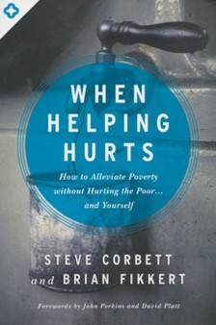

Media link )

Why We’re Recommending It:
Over the years we keep learning that sometimes we are causing more harm to the very same people we are actually trying to help. How does this happen? Corbett and Fickert offer their wisdom and experience on how to avoid the traps that cause damage and instead help us navigate thoughtfully how to minister to those in need in truly Christ-like ways that affirm the humanity of everyone involved.

20/20 Bible Study Book - Christine Caine
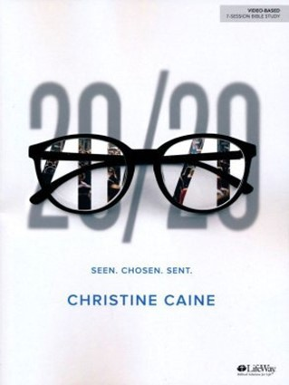

Christine Caine is passionate about seeing every woman equipped to live her life on a mission for Jesus. In this 7-session study, you’ll develop a new understanding of how God sees you and has chosen you to help make Jesus’ name known on this planet. Through biblical teaching and
lessons from her own life, Christine challenges you to share the story of how God's love has transformed your life right where you are. This is a study geared toward women. The 20/20
Bible study book is designed to be used in conjunction with the 20/20 DVD Leader Kit found on
Lifeway, Amazon, and Christian Books.

Why we’re recommending it:
Christine challenges and equips you to share the story of how God's love has transformed your life right where you are.

Love Over Fear: Loving Monsters, Befriending Enemies in a Polarized World - Dan White (book and free group discussion content)
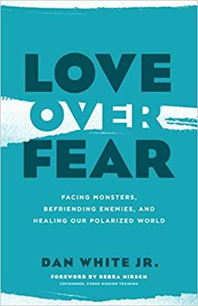

Why We’re Recommending It:
There has never been a more challenging time to thoughtfully discuss our societal and political concerns. Much of our discourse has become toxic and painful. Author Dan White Jr. believes this is an opportunity for the church to give our culture a much-needed example and identifies the need for love in our culture that has become fearful and angry towards their ideological
rivals. You can find the book at Amazon or Christian Books.

What is Q Media? And Why We’re Recommending It:
Think of it as a mini-Netflix channel for our cultural conversations informed
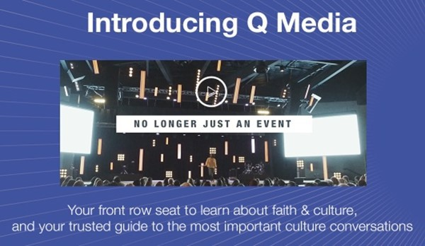

largely by a Christian viewpoint. Q Ideas gathers communicators and leaders around the challenging topics in our society.
We believe groups can be a place for us to learn new ideas, respectfully share our perspectives and be challenged by the convictions of others.
This is a brand-new resource that we are looking for a few groups to experiment for us. You can stream the content on a smart-tv, handheld device. Q Talks are TED Talk style and are either 9 or 18 minutes long and each talk has a set of discussion questions on its talk page.

Would love to set you up with your account, please contact Pastor Tim Ghali directly to get access (and he wants your feedback for the future of this re- source).
STRENGTHENING RELATIONSHIPS

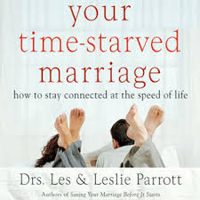
Marriage
Your Time Starved Marriage - Les and Leslie Parrott
https://www.rightnowmedia.org/Content/Series/368287
Why We’re Recommending It:
Here’s the series description:
"After resolving communication meltdowns, finding time together is the number one relational need of most couples. Where does time go? We try to make it. Save it. Seize it. Buy it. And borrow it. And yet time continues to elude too many couples.
The moments you miss together are irreplaceable; gone forever.
In this six-session series, relationship experts Drs. Les and Leslie Parrott will help you better manage the priceless resource of time. They will show you how to reclaim the time you’ve been missing and how to maximize the moments you have together. This is not about being more productive, but about being more connected.”

STRENGTHENING RELATIONSHIPS

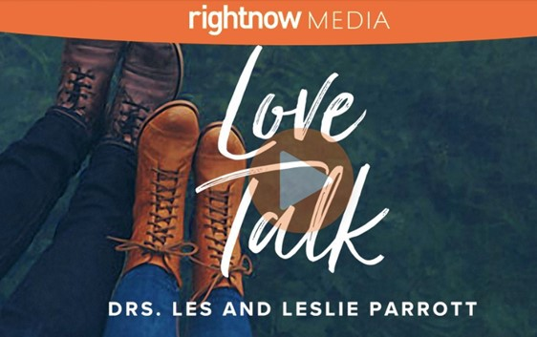

Befriend - Scott Sauls
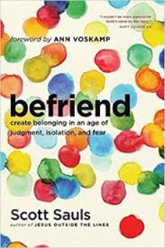

Love Talk - Les and Leslie Parrott (book and/or RightNow Media series)

Why We’re Recommending It:
We like this 5-part video series by Drs. Les and Leslie Parrot that help you determine your personal communication style and learn how you can speak your partner’s language.
Video chapters range from 7-17 minutes and the study features free Leaders Guide and Participant Handouts. Books and workbooks are available for purchase through RightNow Media.

Why We’re Recommending It:
A study on Friendship & Relationships!
Because we can all be better at friendship. Pastor Scott Saul helps us appreciate why
relationships can be so hard to maintain and gives fresh wisdom on how to close the gaps in our friendships.
This is a terrific study for new groups or groups relaunching with new members. It’s intense, fun, and yet interesting and insightful. (Book and/or RightNow Media series)

STRENGTHENING RELATIONSHIPS

Living Life Together - Shauna Niequist
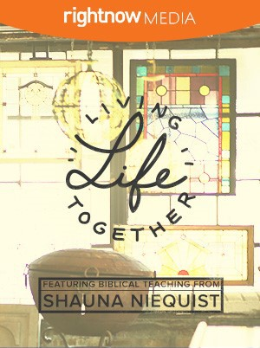

Why We’re Recommending It:
Shauna Niequist asks, “Do you stay busy to avoid deep connections? Do you resist community for fear of being judged? Do you need to reconcile a relationship?” Author and speaker Shauna Niequist is passionate about living life in community. In four intimate sessions, she walks through Scripture, challenging women to step out of isolation and fear and pursue relationships rooted in rest, grace, and reconciliation. Find Leader’s guide and handouts here.

Intentional Parenting: 10 Ways to be an Exceptional Parent in a Quick Fix World - Doug Fields
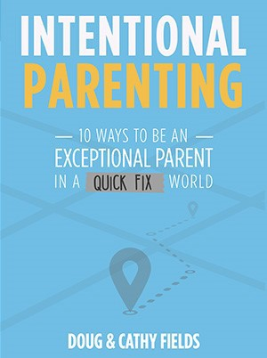

Why we’re recommending it:
Doug Fields is a speaker, writer, and former pastor who has dedicated his ministry to the spiritual formation of adolescents. Throughout his career, he has focused on parenting, specifically what do our children and teens need in their own life.
This 5 session video series is packed with practical wisdom, a bit of humor, and solid
principles in becoming better parents. We also liked that each video is less than 10 minutes long, leaving plenty of time for discussion.

Click here for the video series on RightNow Media.
Archives
Previously Featured Resources – they’re still great, just taking them out of the rotation above.

Galatians: Discovering Freedom in Christ Through Daily Practice - Sue Edwards & Jodie Niznik
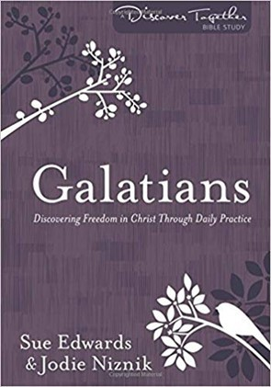

Why we’re recommending it:
This study is a recommended resource for all our groups including women’s, men’s, and mixed.
Dig deeper into Galatians with gifted pastors and teachers, Sue Edwards and Jodie Niznik to discover the nuances of grace that will revolutionize your life. Grace is perhaps the most
misunderstood doctrine of the Christian faith. If we truly grasped its truth, we’d be set free to live in the power of the Holy Spirit and to live out Christ’s law of love with overwhelming joy.
We’d be unstoppable! Each lesson also explores a different spiritual practice that guides you to live what you’re learning.

The study guide is available online at Amazon or Christian Books.

Grace is Greater - Kyle Idleman
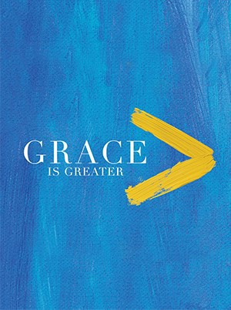

(video-based curriculum from RightNow Media)

Why We’re Recommending It:
The sermon series will be focused on the topic of grace this fall and we want to offer groups another voice on the depth and breadth of the Biblical teaching of grace.

Click here to access video curriculum and leader’s guide, etc. on RightNow Media, or pur- chase the book at Christian Books.

Archives
Previously Featured Resources – they’re still great, just taking them out of the rotation above.

Seamless - Angie Smith
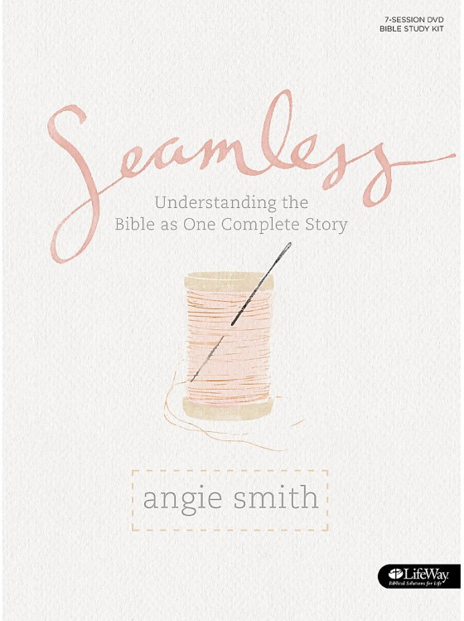

A 7-week study that covers the people, places and promises of the Bible, tying them together into the greater story of Scripture. Participants will gain an overarching understanding of the fundamental layout and meaning of God's Word. Seamless helps replace insecurity that holds participants back with clarity and helps them move forward with confidence in their
understanding of Scripture. Each week of study features key information that ties all of scripture together into the seamless truth of the gospel message and is accompanied by maps, general
Bible facts, and word studies. Plenty of content and supplements for book based only study or use of video teachings. This study can be found at Lifeway or Christian Books.

Why we’re recommending it:
No matter where we find ourselves in the knowledge of the Bible, this is a study that helps you have a balcony moment where you begin to piece together the arc of the Old Testament and New Testament and see more clearly the bigger story of Jesus. As you do, we hope you’ll begin to sense why grace is truly so undeserving and all about the grace and love of God.

The Tech-Wise Family - study for parents by Andy Crouch
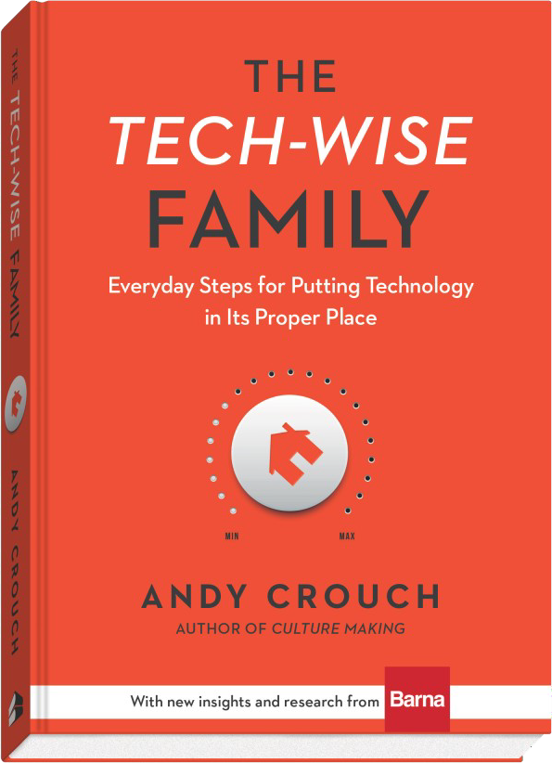

Why we’re recommending it:
Modern families struggle with the role and the exposure of technology in their home life. Working out of his own family experience, author Andy Crouch brings wisdom, data and a call for discipline to master technology so that we “can reclaiming real life in a world of devices.” it does not become a master of us.

In addition to the book, there is a free 21-day Tech-Wise Challenge you and your group can utilize and then discuss your experience: https://www.barna.com/techwisechallenge/.
Archives
Previously Featured Resources – they’re still great, just taking them out of the rotation above.

The book is available at Barna, Amazon, and Christian Books.
Not Alone - A Study on Friendship
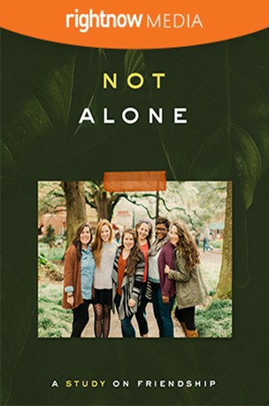

In this six-week study, join Jennie Allen, Lauren Chandler, and Amena Brown as they talk about friendship. Discover biblical examples of friendship, why we need them, and identify the pitfalls, challenges, and joys of friendship. This study has a women’s group leaning but is applicable for all. You can find the study with videos on RightNow Media.
Why We’re Recommending It:
Topics include toxic relationships, boundaries, and how to rebuild broken trust. But most of all, the teachers, real-life stories, and study guides will help you celebrate the
encouragement, wisdom, and love that only comes when you’re not alone.

