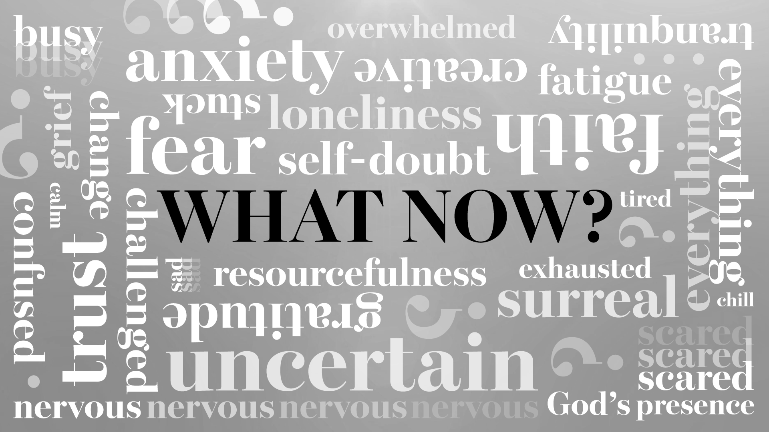

Sermon Study Guide
For the sermon preached on
4/19/2020:
“Hope Has a Name”
I Peter 1:1-13

How to use the Study Guide During Our “Stay at Home” Online Group Meetings
Group life is even more critical during this incredible season. Over and over, group leaders are reporting that suddenly, there is a new hunger to connect, share, pray, and meditate on Scripture together and so we are making these guides available weekly and suggesting a new format during this season.

As you know, our Group Life’s vision is to “practice the way of Jesus.” And while Jesus never had to lead a Torah study over Zoom, he was strategic in his teaching ministry, and we want to be as well.

There are a number of differences between meeting in person and meeting online, ranging from the obvious to the subtle. One is, given our attention spans for online meetings, we want to encourage you to limit the length of your call between 45-60 minutes and we are calling this “Check-In Plus One.” Meaning, spend a few minutes checking in with your group and see if there are any new needs with them (or even amongst their neighbors). "The One" is to spend time in study. As our Stay at Home continues, our desire for meaningful content and interaction will grow. Given our new format, the study guides based on Sunday’s Sermon will be designed to be more application based (as opposed to unpacking the text with the Inductive Bible Study method). You might consider sharing the passage beforehand with your group in hopes that they might spend more time with the Scripture before the gathering.

As always, we are so grateful for you, your gifting, your servant leadership, and all that you do in practicing the way of Jesus in community.

Grace and peace,
Pastor Tim, on behalf of the Group Life Team

“Check-In Plus One”

Welcome everyone to the Zoom call and outline the goal of this call being 45 minutes. Spend 15-20 minutes checking in with one another, then move into a time of prayer, and then spend some time discussing the application of the Scripture passage.

A “Check-in” question might be, “Now that we have completed 4 weeks of our Stay at Home quarantine, how are you doing, and is there anything new that has arisen in your life or in your neighborhood that we can pray about?“
-----
As mentioned, throughout our Stay at Home quarantine, we have shortened our study given the confinements and attention spans on Zoom calls (it’s not you, it’s the difference of interacting over screens versus physically being together in person :). So these three questions are designed to be less inductive, and more practical. So let’s get started.

Our new series is called, “What Now” and it feels like the question we are all asking in one form or another. It’s a question we ask in the midst of uncertainty and trouble and it’s one that’s been asked throughout the ages. It represents an abbreviated thought, “We used to live life a certain way and now we can’t … so how should we live now?”

Q - Pastor Bryan said, “Hope is like oxygen to the soul. You can get through anything when you have hope.” Can you describe a time when hope got you through a difficult time and what difference did hope make in the midst of it?

Q – Life is filled with many ups and downs, times of feeling hopeful and others when you feel emptied. What do you do when you feel you are running low on hope?

Q – I Peter 1:3 reads, “Praise be to the God and Father of our Lord Jesus Christ! In his great mercy he has given us new birth into a living hope through the resurrection of Jesus Christ from the dead” and throughout the sermon, Bryan reminded us of the reason for this hope: the empty tomb and the ancient church’s mantra, “Christ has died. Christ is risen. Christ will come again.”

Bryan alluded that there are many forms of hope that are often described – what do you think makes the living hope of Jesus different than others and how does this bring you courage in the midst of uncertain times?

Let’s close our time in prayer, thanking the Lord that He is our Living Hope and ask him to be with us as we enter into a new week. Let’s pray …

