Thanks for checking out our sermon-based Study Guides! If you’ve never used our Study Guides before, you’ll find some basic instructions at the end of page 2.

Sermon-BASED Study Guide
for the sermon preached on April 18, 2021
Finding Our Way Forward Week 1 - “Devoted” - Acts 2:42-47

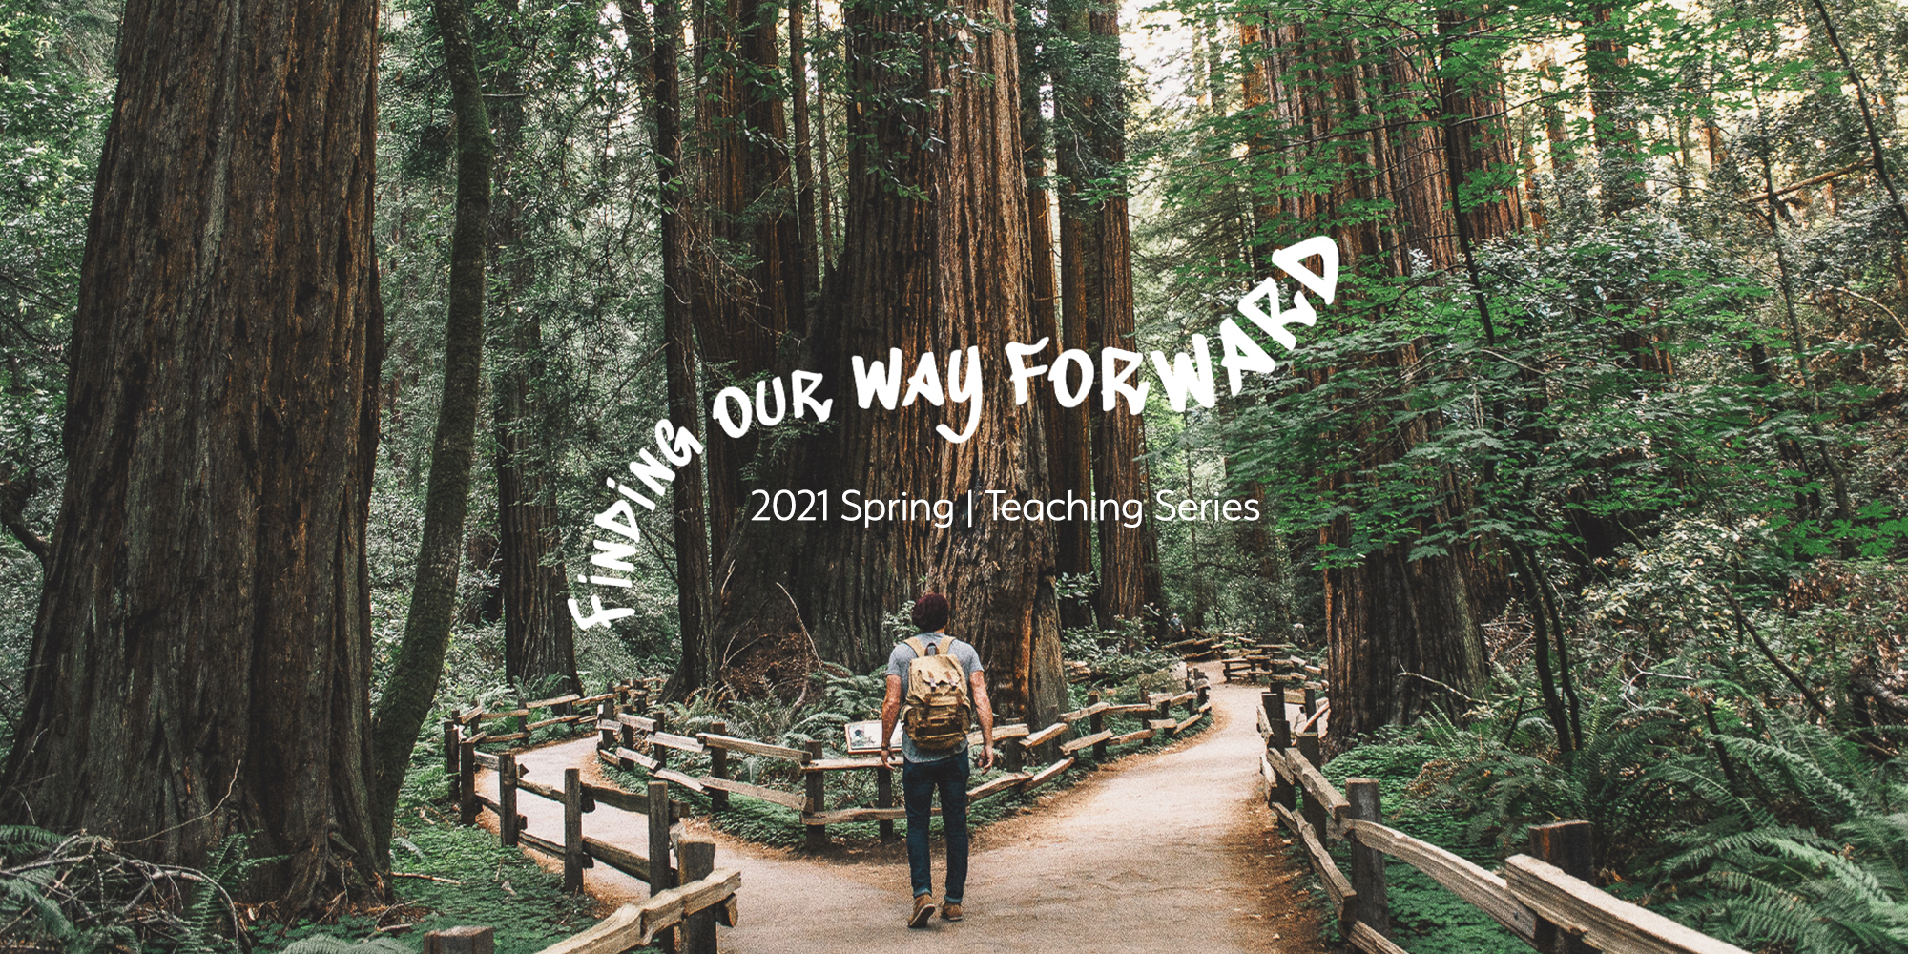

As our society slowly begins a process of re-entry, we begin a new sermon series called “Finding Our Way Forward.” Today’s Christ-follower and today’s church have their own unique challenges in this pandemic world and as we read the book of Acts, we see that the early church needed to find its way forward in light of the revolutionary coming of Jesus and his climatic resurrection that dramatically changed the world. We want to learn from the early church’s example and be similarly surrendered to how the Holy Spirit is helping us as Christ-followers today. The questions below are designed to look at the passages preached, the sermon points made, and with the help of the Lord in community with one another, to create conversation on finding our way forward.

Group Discussion Questions
- We heard in the sermon introduction that Grace Chapel is in the “Reset” phase of our 3-Part Relaunching (Reset, Ramp-up, Relaunch. You can learn more at www.grace.org/relaunch/).
As you take personal inventory today, in what areas is a reset needed in your life? As Bryan explained, where do you need a fresh start, where do you need to do things differently?

- To find their way forward, the early church was in need of a reset. They really didn’t even know they were the “early church.” What they did know was that the resurrection of Jesus had changed everything and so, there was an incredible need to reset their lives, their message, their approach, their worship, their community life … everything!

Acts 2:42-47 gives us a picture of what was going on after the Holy Spirit came upon the disciples at Pentecost. As you read this familiar passage, identify what became new and what had to be reset in this moment:
“They devoted themselves to the apostles’ teaching and to fellowship, to the breaking of bread and to prayer. Everyone was filled with awe at the many wonders and signs performed by the apostles. All the believers were together and had everything in common….Every day they continued to meet together in the temple courts. They broke bread in their homes and ate together with glad and sincere hearts, praising God and enjoying the favor of all the people. And the Lord added to their number daily those who were being saved.” Acts 2:42-47

(Leader Note - Answers of reset and newness might include new/reset teaching, new apostles and leaders, reset practices of breaking bread (think of Jesus’ last words at the Last Supper), new signs and wonders, reset practices of community that included sharing, fellowshipping, prayer, worship, joy, and a renewed blessing from the Lord evidenced by new people constantly entering into their community. Numerous aspects had reset and become new again).

- One of the key points Bryan made was about being a devoted follower of Jesus. (In fact “Devoted” was the title of the sermon). He defined devoted as “to be extremely loving or loyal toward someone or something; it’s to be focused almost exclusively on that someone or something; to be “given over” to it. … to be passionate, enthusiastic even.”
Bryan finished that definition and offered a question that we want to reflect on:
“So let me pause for a minute and ask: Is that how someone would describe YOU when it comes to your faith? Are YOU, are WE, “devoted” to prayer and worship and study and connecting? Is it possible that COVID restrictions and ONLINE church have taken the EDGE off our COMMITMENT to these things? Are we “ENTHUSIASTIC” about serving each other and the world around us? Or have we become so focused on our OWN needs and challenges that we don’t have much time and attention to give to others? WHY were these first believers so DEVOTED? WHAT made them so PASSIONATE?”
Let’s take a few moments and pause and then share the answers on our hearts together.

- Pastor Bryan emphasized the point that the early Christians were seen with such high regard in the community and this is a key reason why they were such an attractive community to join. They rebelled against the oppressive authority of Rome, not with violence and swords, but by proclaiming their Lord Jesus was the only hope of true salvation. They showed love towards those on the margins and shared with neighbors and strangers and they were known for their love. Today we grieve that the Christian church is not seen that way as a whole. Today’s Church is seen by society more through the lens of political affiliations and societal viewpoints and this has led to surveys revealing that half of Americans view the Christian church negatively. While we are not to be motivated by any approval rating, we are motivated by Jesus’ teaching to love others. And so what can today’s church learn from the early church in showing love in this time of reset?
(Leader Note - After a few answers, you might consider reading the quote shared from Sunday by David Kinnaman to keep the conversation going:
“The findings strongly suggest that the perceptions of evangelicals are more barrier than bridge on the road to gaining a hearing for the gospel. As such, [it] requires much soul searching among Christians to discern a way forward.” - David Kinnaman

Leader Note 2 - Likely the answers given will come from a wide range and of course that’s good. Try to facilitate in a way where the defensive reaction isn’t the one settled upon. One of the clear lessons of the early church was that their love for Jesus and “the other” inspired the masses, it was winsome, it showed a better way to live - today’s church and today’s world wants something similar!)

- Last question – in light of our conversation today, how would you finish this sentence.
“To find our way forward, I pray the Spirit would empower me to ____________.”

Prayer Suggestion
We have been hearing all year that we’ll not able to go back to an old normal. Despite our comfortability with former aspects of life, and the many and new challenges of the year, we ought to remember that parts of the “old normal” were not working anyway. We need to find a new way forward and may we do that by seeking the Lord in prayer and asking for the same Holy Spirit that filled the early church and empowered them to do countless extraordinary things to similarly be at work in our lives today. Let’s pray …

How to Use These Study Guides:
- Consider sending out the Scripture passage to your group members ahead of time.
- Begin each meeting with a short time of checking in with one another.
- You may want to begin the discussion by reading the Scripture passage together out loud, or by summarizing the passage if everyone has read it ahead of time.
- Don’t feel like you need to discuss every question included in the Study Guide. Pick one or two to start with, and see how the conversation flows.
- If your group meets over Zoom:
  - You may need to do more overt facilitating over Zoom than you would in person. Feel free to call on people to invite them to share.
  - Try to be sensitive to attention spans over Zoom—keep the meetings shorter than they would be in person.
- Be sure to set aside time for sharing prayer requests and praying together.

Group Leader Support: Please reach out to your Campus Pastor or your Coach if you have any questions about leading your group or concerns about your group dynamic. If you have questions about or feedback on the Study Guides, please reach out to Pastor Tim or Pastor Rachel from the Group Life team.

