Thanks for checking out our sermon-based Study Guides! If you’ve never used our Study Guides before, you’ll find some basic instructions at the end of page 2.

Sermon-BASED Study Guide
for the sermon preached on May 2, 2021
Finding Our Way Forward Week 3 - “The Way of the Spirit” - Acts 1:1-14

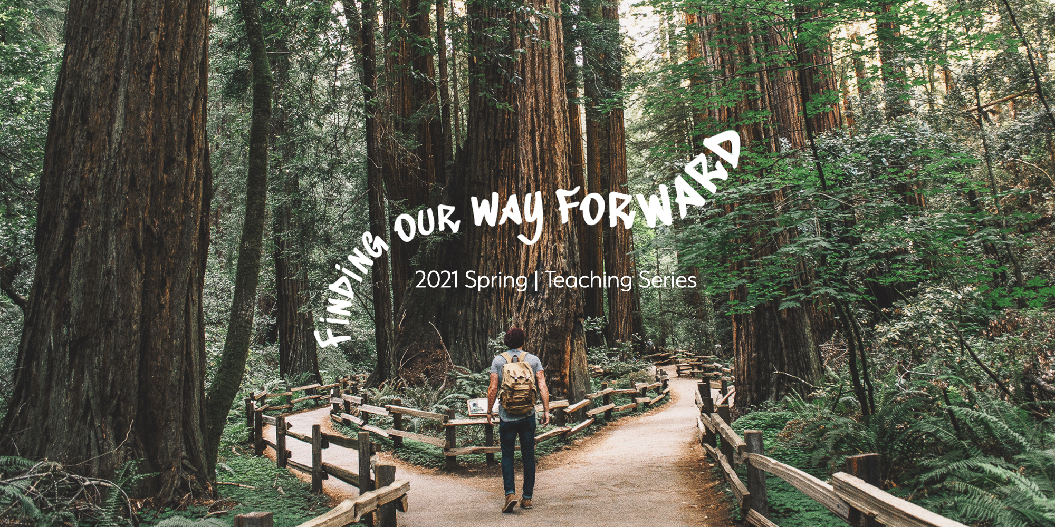

We come to week 3 of our series Finding Our Way Forward. As we emerge from the pandemic, how will we find our way in a world and a church that has been dramatically changed by all we’ve been through?

As Pastor Bryan said, to find that way we are returning to the early days of the church; to the very first Jesus followers, as they found their way forward after His resurrection and return to heaven. So we’re turning to a book of the Bible called Acts, which describes the birth and growth of what we call, the Church, but which at the time was simply known as, the way. We want to learn from the early church’s example and be similarly surrendered to how the Holy Spirit is helping us as Christ-followers today. The questions below are designed to look at the passages preached, the sermon points made, and with the help of the Lord in community with one another, to create conversation on finding our way forward.

Group Discussion Questions
Q - In the beginning of the sermon, Pastor Bryan told the story of the Great Awakening which began with a post-Revolutionary America that showed our nation’s population forfeiting their faith in Christianity. The decline was so steep that it was assumed that the Christian faith would be extinct in the following generation. A group of pastors called for the commitment to pray, people begin to gather more and more and eventually the revival broke out in what is now referred to as the “First Great Awakening.”
As you heard Bryan’s introduction and as we reflect on it now, what thoughts echo through your mind, what similarities do you feel present-day America has with post-revolutionary America and what key differences do you think there are?

Q - One of the passages the sermon mentioned was when the resurrected Jesus was eating with his disciples and they ask him if he will not restore the kingdom to Israel. Read Acts 1:6-8 – How does Jesus respond? And why do you think the will of God is for Jesus to ascend into heaven, send the Holy Spirit and bring His Kingdom through the community of the Church?

Q - Some have called the Holy Spirit the “forgotten member” of the Trinity. When you consider the person and work of the Holy Spirit, what is a truth that impacts your life and what is a question you have?

Q - The “Big Idea” of the sermon was “We find our way forward when we seek the power and presence of the Holy Spirit.” What have we seen in this passage and received in this sermon that can help us seek the power and presence of the Holy Spirit in finding our way forward?

Prayer Suggestion
May we spend time in prayer by being encouraged that the Holy Spirit is always with us and desires to work through us; may we seek the Spirit’s power and leading to reach others and to meet the needs around us and may the Lord awaken the church to bring healing, love, and joy to our community, our nation, and our world for God’s glory.

How to Use These Study Guides:
- Consider sending out the Scripture passage to your group members ahead of time.
- Begin each meeting with a short time of checking in with one another.
- You may want to begin the discussion by reading the Scripture passage together out loud, or by summarizing the passage if everyone has read it ahead of time.
- Don’t feel like you need to discuss every question included in the Study Guide. Pick one or two to start with, and see how the conversation flows.
- If your group meets over Zoom:
  - You may need to do more overt facilitating over Zoom than you would in person. Feel free to call on people to invite them to share.
  - Try to be sensitive to attention spans over Zoom—keep the meetings shorter than they would be in person.
- Be sure to set aside time for sharing prayer requests and praying together.

Group Leader Support: Please reach out to your Campus Pastor or your Coach if you have any questions about leading your group or concerns about your group dynamic. If you have questions about or feedback on the Study Guides, please reach out to Pastor Tim or Pastor Rachel from the Group Life team.

